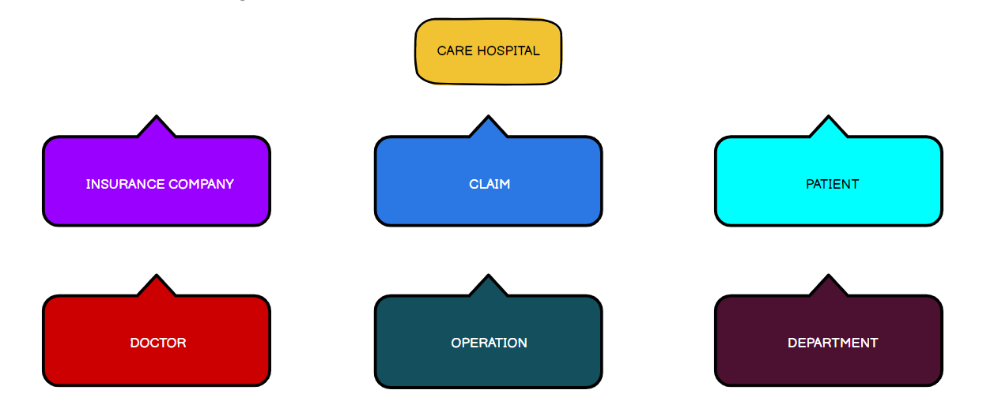

The Hospital is having all the which includes Insurance company , Claim , patient,Doctor ,Operation,Department

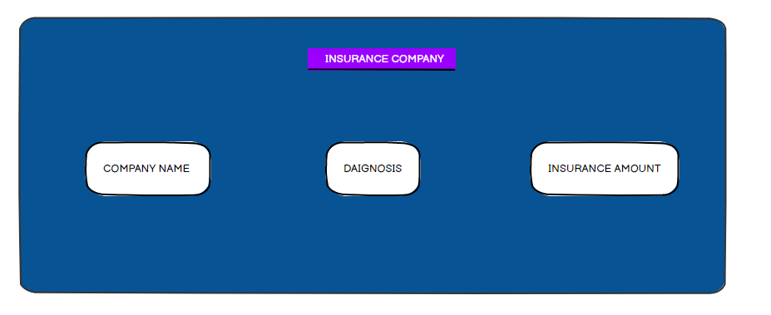

In Insurance company when we click on insurance company we get company name , what issue we have , insurance amount which we have taken before

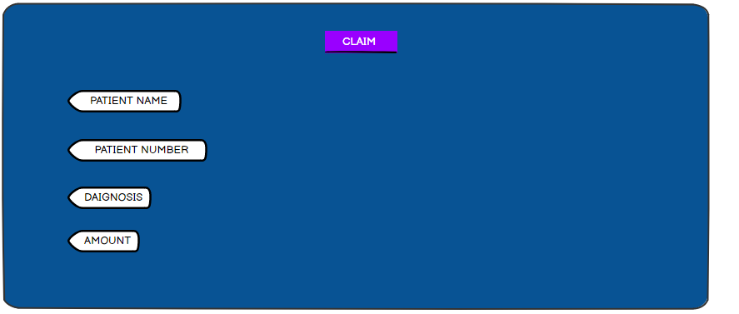

Claim is about they is the patient name , patient number, Daignosis,amount, and the claim depends on which we patient details

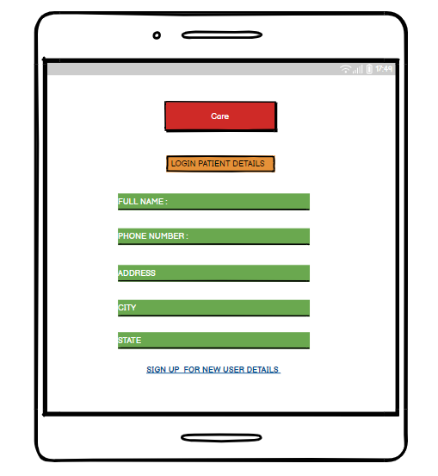

When we click on patient this is already extending patient details login we get FULL NAME ,Phone number, address ,city and state . If it is a newuser need to sign up

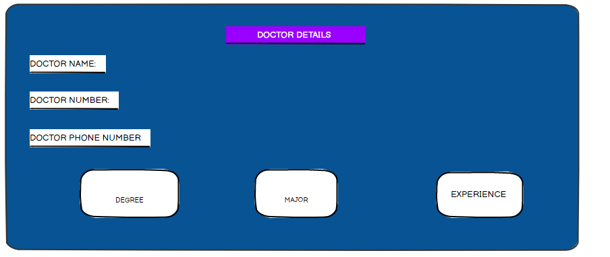

The doctor details for the doctor number,phone number ,degree ,major

The 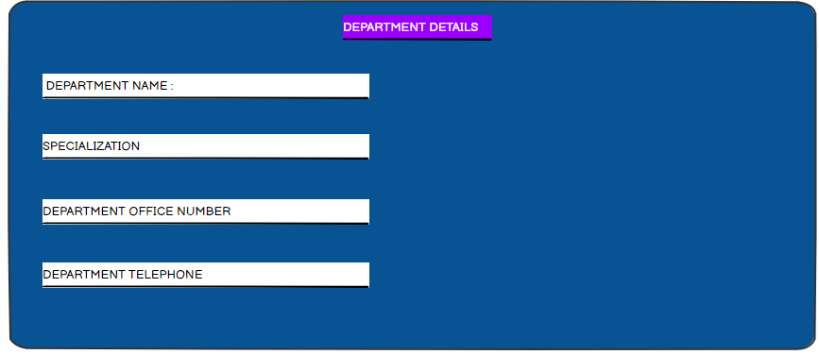

When we click on department and we get the details , phone number ,telephone number